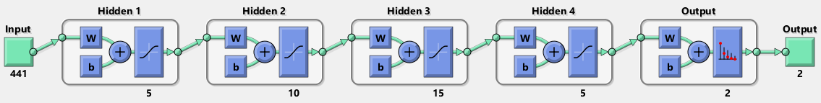

net = patternnet([5 10 15 5]);

net = train(net,x,y);

%view(net)

t = net(x_test);

perf = perform(net,t,y_test);

irisOutputs = sim(net,x_test);

[tpr,fpr,thresholds] = roc(y_test,irisOutputs);

figure

plotroc(y_test,irisOutputs)

